OPEN SKY ADVENTURE CAMP 2026
The “Open Sky” 2026 project is an adventure designed for young adults affected by CCHS, made to be accessible to the needs of all participants. It is above all an opportunity to connect with nature and embrace new cultural experiences in a unique setting. Seven days among the mountains and the enchantment of the Trentino Dolomites, together with the Campo Base and AISICC staff, instructors and local guides, and other CCHS young adults, in a stimulating and safe environment.
Info about Open Sky Adventure Camp
ARRIVALS: arrivals are scheduled for Sunday, July 19th from 2:00 PM at Hotel La Pineta, Località Pineta, 38075 Fiavè TN – https://lapinetahotel.info/. Participants will be responsible for their own travel arrangements and must reach the site independently. In case of specific needs, especially for international participants, we can arrange transportation from the nearest airports, as indicated in the information brochure.
DEPARTURES: departures will be on Sunday, July 26th from Hotel La Pineta, after breakfast.
Families who will pick up participants at the end of the camp are invited to arrive the day before, Saturday, July 25th, after 3:00 PM (arriving directly at Castel Campo, Località Castel Campo, 38075 Fiavè TN), to meet the group and take part in the final evening together. Families must independently book their own accommodation in the area for Saturday night, preferably in a different location than the one used by the participants.
FREE TIME: this project is designed to spend time together with the people we will meet there. We will spend evenings around the campfire, and “free” moments are also meant to be shared with the group.
The camp will be dynamic and participatory: we ask everyone to be present, active, and ready to socialize.
PHONE USE: using a mobile phone at camp will be allowed but discouraged during all group moments such as activities and meals. A WhatsApp number will be provided to request information efficiently. A WhatsApp group will be created between participants and staff for quick communication during the session.
WHAT IS INCLUDED: Participation in the Open Sky Adventure Camp is free of charge. Specifically, all meals, accommodation, and activities are included. Travel costs and arrangements are at participants charge.
WHAT TO BRING: before the camp begins, a packing list will be provided; no specific technical equipment will be necessary! You will, of course, need to bring:
• all devices and supplies required for ventilation management and monitoring
• medications for ongoing or potential treatments
• for international participants, adapters for Italian power outlets and power strips
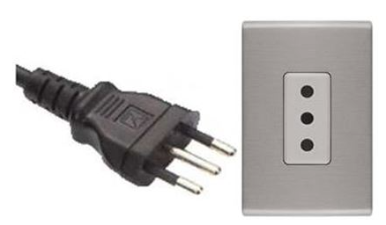

OPEN SKY ADVENTURE CAMP 2026
APPLICATION FORM

complete the form and submit it via email to aisicc@sindromediondine.it

PART 1 – PERSONAL DATA
Partecipant’s Personal Information
Name and Surname
Date of Birth |  | M ☐ F ☐ X☐
Address
Mobile Phone | Email
Parent or Legal Guardian Information (mandatory if the participant is a minor)
Name and Surname
Date of Birth
Address
Mobile Phone | Email
Emergency Contact Information
Name and Surname |  |  | Mobile Phone
Grado di parentela / relazione con il partecipante
Primary Physician Contact Information
Name and Surname |  |  | Mobile Phone
Reference Clinical Center Contact Information
Name and address of the healthcare facility

Phone Number

PART II – DAILY MANAGEMENT
Participant’s specific needs

What specific attention is required from the caregivers during the camp (care, supervision, adjustment of night-time ventilation, etc.)

During the day | During the night

Checks performed independently by the participant

During the day | Before bedtime / during the night

Food allergies / specific dietary needs

Other known allergies

PART III – TELL US MORE
Are there any aspects of this program that worry you? If yes, which ones and why?
(shared accommodation, demanding activities, etc.)

Which program activities are you most interested in?

Is there something you would like to do during this week that you did not find in the list of planned activities?

Remember that this APPLICATION FORM must be sent by email to
aisicc@sindromediondine.it

