WAY UP Extra 2024 (English speaking YACs)
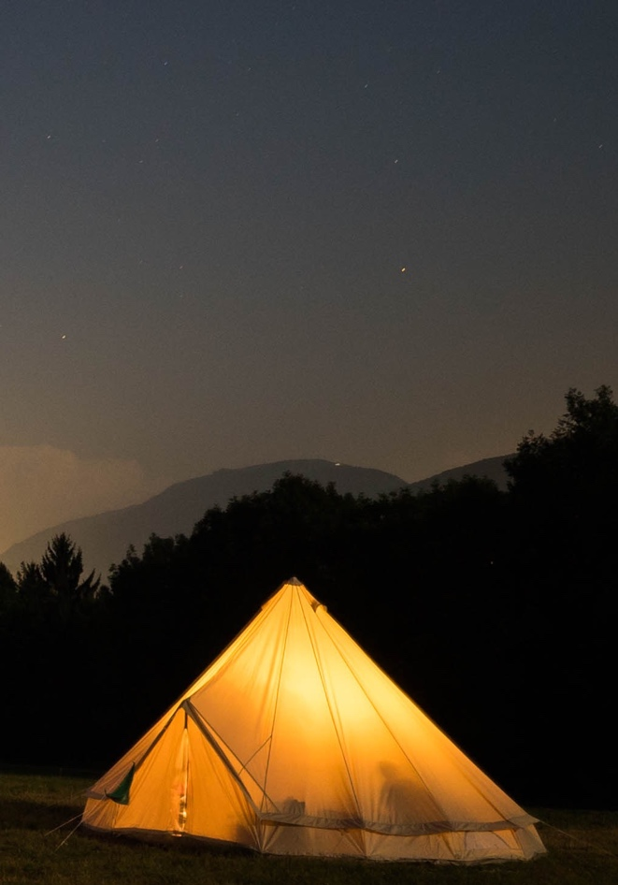
The ultimate Italian adventure! Set off on an unforgettable journey with Associazione Campo Base and join Way Up- our program in Trentino for Young Adults impacted by cancer. Open to English speakers from anywhere in the world- this is program centred around Alpine sports such as hiking, climbing, sailing, rafting, and much more. We will also dive into Italian Culture and History with a chance to stay at Castel Campo- a centuries old castle located at the foothills of the Dolomite mountains. The 2023 “Way Up” program - is an adventure designed to be athletically challenging, yet accessible to all participants. Above all, it is an opportunity to connect with nature and embrace new cultural experiences in a unique context. Experience 7 days among the mountains and the enchantment of the Trentino Dolomites, in the company of the Campo Base staff, local instructors and guides and other young adults affected by Cancer.

Join us for the opportunity to dive into Italy’s rich history and culture whilst staying at the marvellous centuries old castle called “Castel Campo”, which is privately owned and managed by the Rasini family.

GETTING THERE: We are aiming to make the logistics of travel as easy as possible but of course we are a little way off the beaten path so thank you for making the effort to join us in the dolomites!

One resource we recommend is www.rome2rio.com, which can be super helpful in planing a multi leg route. For reference, these are the Castel Campo coordinates: https://goo.gl/maps/QZ4qjT4VsYSGkpxm6

Our closest airport is VERONA Catullo (VRN) where the shuttle bus will collect all participants on arrivals day. If you would like to fly into a different airport and make your way to Verona consider that our , second closest is Milan Bergamo, and third closest is Milan Linate. Milan Malpensa (MXP)and Venice(VCE) are equidistant. If you are traveling from outside the EU/Shengen region, please make sure you have appropriate travel documents/VISAs before booking your flights.

ARRIVALS: we will rendezvous with the entire group on September 21st 2024 at VRN airport. If you would prefer to make your own way please expect to arrive in Castel Campo (Fiave’ TN) on the same day between 2 and 4pm. Our closest train station is Trento- from there there is a bus to Ponte Arche (our nearest bus station) or public taxis available for hire.

DEPARTURES: Departures will be on September 28th 2024 in the morning with a group drop off TBD.

PARKING: It is possible to park the car near Castel Campo. You will not need a car during the program unless you want to use it in your free time.

FREE TIME: This project is designed to be together with the people we will meet. We will spend the evenings together around the bonfire, as even the "free" moments are designed to be shared with the group. While no activity is obligatory, we ask that participants commit to participating in daily activities unless they are in need of rest.

CONNECTIVITY: There is no WI-FI in Castel Campo. We ask you to organise your personal and professional internet needs in such a way that you can disconnect (almost) completely from phones and laptops. We will ask you not to use cell phones during activities, meals and programming unless it is to take photos.

WHAT IS INCLUDED: Participation in WAY UP is free for eligible applicants whose participation has been confirmed. This will include: All meals, all programming and activities, accommodation. Please note that participants are responsible for their own travel up to the rendezvous in VRN airport and after drop-off on departure day. Our programs coordinator is happy to help look at flight options and other travel if necessary!

ALCOHOL AND RECREATIONAL DRUGS: We have a zero alcohol and drug policy while on site and during the program.

WHAT TO BRING: We will send a packing list to confirmed participants. No technical equipment is required apart from a good pair of mountain boots, medium-sized backpack, and appropriate clothing.

Application form
WAY UP ‘Extra'(English speakers) – September 2024
FORM A - Participant info
To be filled out by applicant
PART 1
This information is meant to help us create a program where everyone can have fun and be safe. Please do not omit information that could help us achieve this goal!
Full Name :
Emergency contact:
Name, telephone number and email:

Relationship to you:

Applicant details
DOB: | National ID #: | M F X
Address:
Cell phone #: | Email:
Would you prefer to be contacted via (please tick). email o phone o WhatsApp o
Do you have children? Yes No Prefer not to specify
Please let us know if you are employed/a student/other:
Medical Information
Cancer Diagnosis:
Date of Diagnosis:
Are you currently receiving medical care that relates to this diagnosis?? Y / N (Please describe)
Are you receiving maintenance care? Y / N
Are you in remission? Y / N As of (date):
Have you had any relapses? Y / N
Have you undergone chemotherapy? Y / N Date of most recent chemotherapy:
Have you received radiotherapy? Y / N If yes, in which part of the body:
Please name any other conditions:

At which hospital/clinic/medical center were/are you treated?
Please list all surgeries you have received:

Please list all medication you are receiving and frequency:
Name of med Dosage Intake Day/Time Notes

Can you take your medication autonomously? Y / N
Do you currently have a CVC or port? Y / N Do you have any open wounds? Y / N

Are you able to bathe in a bathtub/pool/lake?
Do you have any amputations/prosthetics?
Do you use any walking aids (crutches, wheelchair, other)? Y / N If yes, please describe.
Have you ever had vertigo/dizziness/feelings of instability or loss of balance? (If yes, please describe)
Can you climb a 4M vertical ladder without assistance? Y / N
Can you climb 3 flights of stairs without assistance? Y / N
Have you ever had a seizure?
Do you have cognitive or sensory challenges? Please describe.
Are you covered by a tetanus vaccination? Date of last recall:
Please list any allergies (food, animals, medication.._):

PART 2 – Program and activities
To ensure safety and fun for all participants, we are using this section to describe some challenges that might arise in the scheduled activities.
Please don’t let these worst case scenarios or questions scare you! We try to imagine extreme cases in order to be able to collect as much information as possible before the project, and consequently to be able to better structure it according to the individual needs of each person.
The answers you give here will not be decisive for your participation/exclusion from participation: please be as sincere as possible when imagining yourself in each situation.
Sample Program Way up 2024 (this is subject to changes)

Day 1 Day 2 Day 3 Day 4 Day 5 Day 6 Day 7

Castle tour Sailing Climbing Mountain Trek Rafting Yoga/ Departures
At Lake Garda And night at lodge Free afternoon
Briefly describe your physical activity experience and whether you currently participate in sports/are physically active
Do you usually go walking or play sports? (Please note: Living a “sporty” lifestyle IS NOT a requirement for participation!)
Sailing on Lake Garda
Activity description
Sailing on Lake Garda is a wonderful way to start our adventure. We will spend 2 hours in total on 5-person catamarans and under the constant supervision of an on-board instructor, who will guide the group in an introduction to sailing (basic manoeuvres and boat handling). We will be wearing wetsuits for the duration of our time on the water.
‘Worst case scenario’ risks and concerns: exposure to wind and cold water, prolonged sun exposure, dehydration, swimming (optional), seasickness, open wounds requiring a waterproof dressing.

What emotional/physical challenges (if any) does this activity present?: (Describe)

Are you comfortable with an exposure to wind or cold water:

Are you comfortable swimming in fresh water:

Describe your previous sailing and swimming experience:

Other concerns/questions:

Rock Climbing
Activity description
For this epic activity we will be accompanied by one or more qualified alpine guides who will show us the basics of rock climbing on outdoor natural rock. Participants are required to wear a harness and helmet (provided) and appropriate footwear. We will spend the day practicing climbing and belaying techniques. In the middle of the day there will be a picnic lunch.

Some things of potential concern may be: possible anxiety/panic due to heights; strain on arms, legs and back muscles. Please note we will not be close to a indoor rest room during this activity.

Have you ever been rock climbing? (Please describe)

What emotional/physical challenges (if any) does this activity present?:

Other concerns/questions:
Rafting

In collaboration with a local organisation, we will go sailing on the wild waters of an Alpine river. We will be accompanied by expert guides and will undergo a briefing on safety and raft commands before getting into our 6 person rafts.
We will wear wetsuits, life jackets, boots and helmets, and we will use a paddle to control the boat. We will get wet with the cold water from the river, but we will be protected by wetsuits. Falls from the boat are rare.

• Describe any difficulties with vision, hearing, balance, use of limbs:

Is there any particularity or physical difficulty that we should know about or that you think may limit you in this activity?

• Other concerns/questions:
High Altitude Trekking and Night at Lodge

Description
The excursion to the alpine refuge (at 2000-2500m) is a fantastic opportunity to experience the mountains. Spending the night in the refuge is a unique experience, and will likely be an exciting challenge for everyone involved. Weather permitting, we will participate in a guided Via Ferrata, climbing near the refuge, and visit a nearby cave before returning to the valley. We will eat and sleep at the refuge.

A Via Ferrata is an alpine route with artificial structures and equipment to facilitate access and ensure safety. This activity involves the use of steel cables, brackets and metal ladders. Using a via ferrata kit, we will be secured to the cable, which limits any fall. The via ferrata in which we will take part is an exciting route of medium difficulty which includes exposed rock walls, vertical stairs and quite steep passages. Our guide will accompany us on the 2.5 hour excursion in small groups so that each participant feels adequately supported.
Since this may be the most challenging time for many of the group, we will describe the potential concerns and difficulties as much as possible:
- To reach the start of the trail we will move off-road on narrow and exposed roads
- Sport at altitude may feel different from “normal” physical activity - physical fatigue could lead to shortness of breath, exposure to heat/cold
- “Altitude sickness” is characterized by a set of disorders that can arise when the subject finds himself in an environment with a lack of oxygen (hypoxia): these include headache, nausea, loss of appetite, dizziness, exhaustion, insomnia.
- Please note we will each carry a circa10kg backpack for 2.5 hours uphill and 1.5 hours downhill.

• Do you often go walking (in the last 6 months, have you walked for more than 45 minutes)?

• Have you ever been above 2000 meters? Have you ever practiced sports at high altitude? (If yes, please specify)

• Have you ever suffered from altitude sickness (discomfort due to altitude)? If yes, describe the circumstances.

• Describe ANY health conditions/concerns we should know about when planning this activity. (General fitness level, breathing issues, dietary needs, insomnia/difficulty sleeping, etc.)

• Please note if you have lung health complications, issues with /Deep vein thrombosis?

Other concerns/questions:
Yoga
OHMMMMM! This 2-hour yoga workshop will take place in the Castel Campo barn. This class is open to all levels and will include breathing exercises, partner work and meditation.

• Have you ever practiced yoga?

• Describe any injuries/physical problems we should inform the instructor about:

• Other concerns/questions:
Describe other issues that could interfere with the activities proposed in the program (heart disease, emotional instability, taking anticoagulant drugs, thrombosis…)

Have you ever had symptoms of depression, stress or psychiatric illness that have limited your daily life or could affect your potential participation?
Part III- Tell us more!
How did you hear about Way Up/Campo Base?

Why do you want to take part in the program?

Are there any aspects of this program that concern you? If so which ones, and why? (accommodation in shared spaces, discussion with other people with pathologies, sports program...)
Which elements of the program are you most excited about?

:) THANK YOU!

AUTHORISATION FOR RECREATIONAL ACTIVITIES AND PROCESSING OF PERSONAL DATA AND IMAGE USE
I hearty declare that I, applicant (name, surname) DOB (dd/mm/yyyy):

Have read and agree to the following:
1. Activities with Campo Base
I am aware that, during their stay at Castel Campo and the APS ETS Base Camp Association, participants will be able to engage in recreational activities (excursions, camping, sports and activities, etc.) carried out with the preparation of specific precautions and suitable safety measures aimed at preventing risks of accidents and under the supervision of expert and competent personnel appointed by Castel Campo and the Campo Base Association to manage these activities.
1. In the event of injury to me, I hereby consent and authorise the administration of all treatments and tests that may be considered advisable or necessary in the judgment of any qualified medical personnel; and
2. I understand that as a condition of being a participant of below listed camp activities or activities that are incidental or related to the same,​ I will provide complete medical insurance coverage for any medical expenses which may be incurred. All medical bills will be sent to me for payment or for forwarding to my insurance company.
3. I have read and understood this form and I assume all risks and liabilities which may result from my participation in any and all camp activities including, but without limitation to the following: swimming, rappelling, white water rafting, archery, climbing wall, sailing, bushcraft, camp out, hiking, nature trail, etc.
4. I assume all risks and liabilities which may result from my participating as a general participant and release and forever discharge and hold harmless Castel Campo and Campo Base Association, its employees, representatives, and agents from any and all actions, causes of action, claims, demands and liabilities arising out of injury to or damage sustained by me.
5. I agree to indemnify the Campo Base Association against any and all liability or loss, and against all claims or actions based upon or arising out of damage or injury to persons or property caused me.

Date Signature

- Priavcy and Data Handling (Please circle one)

I AUTHORIZE I DO NOT AUTHORIZE
Associazione Campo Base APS ETS and Castel Campo to carry out/have carried out the processing of my personal data for the purposes and with the methods indicated in the information itself.
(Authorization is necessary for participation in the activities of the APS ETS Base Camp Association. For further information contact info@associazionecampobase.org)

Date Signature

2. Photos and Video of the participant (Please circle one)

I AUTHORIZE I DO NOT AUTHORIZE

Association Campo Base APS ETS and Castel Campo to carry out/have carried out, with the use of any technology, recordings of my image and to use it for illustrative material (photographs, audiovisuals etc.) in order to promote the work of the organization, for promotional material (brochures, website, social media, etc.), as well as printed media of either Castel Campo and the Association Campo Base APS ETS

Date Signature

Information on the management and storage of personal data for participants

Below you will find the information required by current national legislation and EU Regulation 2016/679
Who we are | Associazione Campo Base ONLUS promotes assistance and support initiatives in the social sphere, especially for people with serious illnesses or psychosocial distress and is the Data Controller of your data.
What obligations do you have? | We remind you that you have the right to decide whether or not to provide us with the requested data, but otherwise we will not be able to proceed with registration and participation in activities with Campo Base.
What data we process | For the purposes indicated in the information, we will process common personal data and in particular personal data (name, surname, address, telephone number, e-mail and other contact details) and particular personal data such as those relating to the state of health.
Why and how we process your data | We use IT and paper tools to process the data you provide, in order to manage your participation in our activity; in particular, your data is processed to allow the administrative and insurance management of your participation or association, and to allow qualified staff to consciously and preparedly manage your participation in our activities.  Once you have completed your participation in our activities, your data will be archived electronically in suitable media (database and software), and for short periods in paper form; this support will then be destroyed.  Common personal data and contacts may also be stored on mobile devices and used for communications relating to the association's activities by telephone, text message, email and other messaging services.
On what basis we use your data | The processing of your data is based on consent. In the case of members, it is based on the associative relationship itself.  We remind you that the data we request from you are essential for the correct planning of the activities with you, in order to guarantee an experience that is as safe as possible and adapted to the needs of the participant.  If you do not intend to give consent, please contact us for further information on your participation at info@associazionecampobase.org
To whom we will forward your data | The data collected may only be known to personnel specifically in charge of processing operations and may be communicated to:  - Internal staff at Campo Base, both paid and voluntary;  - Staff of supplier companies who may need them to carry out their work as best as possible (canteen);  - External consultants who plan activities and who need this information for their correct management;  - Law firm (in case of disputes);  - Insurance bodies (if necessary).  The data processed will not be disclosed, much less transferred to third parties, nor shared . They will be communicated to other qualified parties exclusively to carry out the operations of the association and to provide information on the activities of the Association. The data will not be transmitted outside the European Union.
How long we will keep your data | We will retain your data in our archives for the period necessary to manage your participation and in view of your subsequent participations, to document our activity and also to respond to your data recovery needs.  In any case, the data will be kept for a maximum of five years from your last participation . After that, only some of these will be preserved for reasons of historicity, but they will be made anonymous.  For members , the personal data relating to the members register will be kept according to the terms of the law.  It is understood that your data will be immediately deleted in the event of your signed cancellation of the Membership or at any time in which you decide to exercise the right to be forgotten (deletion) of the data; in this case we will no longer be able to honor what is stated in the signed membership.
What obligations do we have towards him | We have an obligation to respond to your requests to know how and why we process your data; we also have the obligation to correct incorrect data, integrate incomplete data and update data that is no longer accurate; finally, we have the obligations to delete the data and limit the processing; we are obliged to stop processing if you no longer agree; we are obliged to provide you with the personal data concerning you in a commonly used and readable electronic format or to transmit them to another Data Controller indicated by you.  If necessary, contact us via email at info@associazionecampobase.org so as to verify together whether all the conditions required by law are met and to enable us to respond to your requests in the quickest and most effective manner.
Who can you turn to in case of our shortcomings? | If the response from us is not satisfactory, you can contact the Data Protection Guarantor. www.garanteprivacy.it

For further information or clarifications you can contact us at info@associazionecampobase.org or at number 3474859654.Fiavè, 31 January 2024 Thea Rasini - President of the Campo Base Association ONLUS

